AYSO Region 125 Refund Request Form

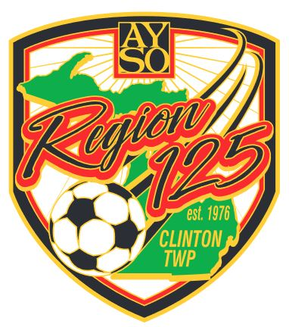

Partial Refunds (Registration Fee minus $50 per player) will be made for Summer registration requests made prior to July 14th. There are no refunds issued for players that register midseason (Winter registration).

Please fill out the following form and return to registrar@ayso125.org

Player name: ______________________________________________

Person requesting refund: ______________________________________

Relationship to player: _________________________________________

Reason for refund: ____________________________________________
________________________________________________________________________________________________________

Registration date: __________ # of players registered: _____________

Amount paid: _____________

Signature: _______________________________ Date: _____________

Mail refund to: ________________________
________________________
________________________

… ……. . . . . . . . . . . . . . . . . AYSO USE ONLY. . . . . . . . . . . . . . . . . . ……..

AYSO volunteer handling refund: _________________________________

Date of refund: _________ Amount of refund: _______ Check # ______

Comments: __________________________________________________

